**Lab Section (Day/Time)_______________________**

**Names of Student with ID# 2022214880**

**Student _Li Xianzhe________ Instructor signature ______________________**

**NAU + CQUPT**

**EE 188 Lab 8**

**Complex Power in AC Circuits**

**Introduction:**

In **passive AC circuits** with both reactive and resistive elements (inductors, capacitors and resistors), **Power** must be **complex-valued** in order to account for the energy expended in actual work (Watts) and that which is tied-up in the maintenance of expanding and collapsing electric and magnetic fields in the reactive elements (Vars).

**Complex Power** in sinusoidal signals is best accounted for by using **complex-valued** notation.

The formula for **complex power S** in a circuit with a current and voltage at a port is given by

**S = ½ VI* (**VA)

where **V =** V/θv is the **voltage phasor** (V)

**I =** I/θi is the **current phasor** (A)

**Phase angles** /θv and /θi are **with respect to a reference 00 elsewhere.**

**Note** that the phasors are **peak values** and **not rms values** in this expression. If **rms values** are used, the **½** factor would already be accounted for. For this exercise, we shall stick with **peak values**.

In **rectangular** and **polar** forms **S** is also expressed by

**S = P + jQ**

where **P = real power** (Watts)

**Q = reactive power** (Vars)

**S =** S/θp

where S **= apparent power** (VA)

θp **= power angle** = (θv – θi) (electrical degrees)

The factor **cos(θp)** is defined as the **power factor** (**PF**), and is an indication of the amount of available **real power** (of the **apparent power** S) that can be **delivered** or **absorbed** by the circuit at the input.

**Procedure:**

Set-up the following circuit, adjusting the function generator to

**vs(t) = 0.5 cos(2π500t)** volts.

**Note** that the **load** is between nodes **A** and **B**, which is **R2 in parallel with the R3 - C1** branch.

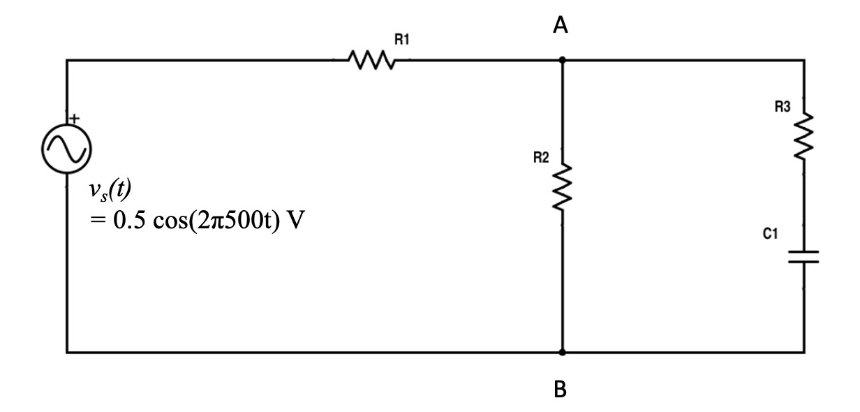

**Measure** and note **the exact resistor and impedance values:**

**R1 = 2.7kΩ => _____2701.7Ω___________(measured)**

**R2 = 3.6kΩ => _____3693.3Ω___________(measured)**

**R3 = 4.3kΩ => _____4288.6Ω___________(measured)**

**C1 = 0.1µF 🡪 ZC = -j/ωC = _____-j3183.1Ω___**

**Activities A, B & C**

1. **Phasor, Impedance & Power Calculations:**
2. Calculate **ZLoad** (show all steps, as done in lectures)
3. Calculate **ZT.**
4. Calculate total current **IT**.
5. Using **voltage division**, calculate **VLoad**.
6. Calculate total complex power **ST**
7. Calculate load complex power **SLoad.**
8. Show that the **total complex power** equals the **load complex power +** the **real power** in resistor **R1** (which will also have to be calculated).
9. **Measurements:**

Using both channels of your oscilloscope,

1. Measure the **input voltage signal** and use it as **reference 00**

🡪 phasor **Vs = 0.5/00** (volts)

1. Measure the **load voltage signal**:

**VL =_**V **(phasor)**

and use it to **calculate SLoad** and **ST** of **part A** above.

* **Clearly show all your steps and calculations, as done in class!**

1. **Drawing graphs:**

Plot on the Complex (Re, Im) plane the 3 separate graphs below:

1. All **Impedance Vectors**, showing that they **add vectorally**

**ZT =** ZT/φT = **ZLoad + R1**

* **All units are in Ohms (Ω)**

Example – drawing impedances

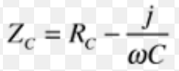

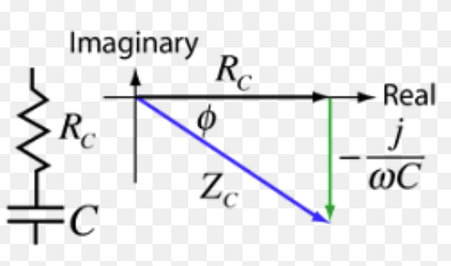

1. The **Complex Power Vectors**, showing that they **add vectorally**

**ST = SL + PR1 = PT + jQT**

* **All units are Power units (VA, Vars & Watts)**

Example – the power vector

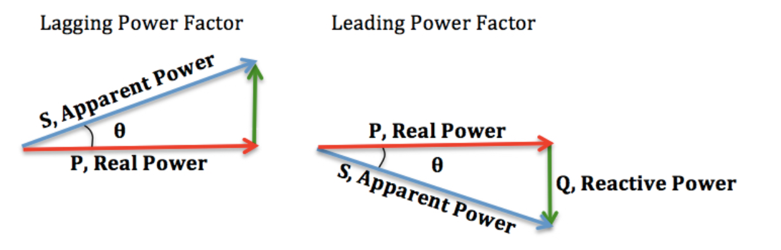

1. The **Phasor Vectors** for **VS = 0.5/00 (ref)**, **IT** and **VL**.

Example – drawing phasors

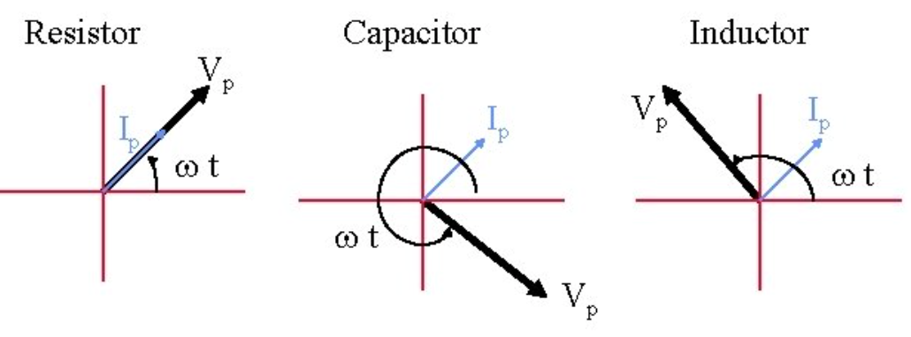

**Note:** You will have to put in the proper scales and units for x- and y-axis in each of the complex-plane graphs below



Impedance (kΩ)



Complex Power (VA, Watts, Vars)



Phasors (volts & mA)

